**Memo**

**To:** Dr. Derek Ross

**From:** Troy Dabney, Courtney Ferriter, Katy Goodman, and Dana Stuckey

**Date:** November 21, 2013

**Re:** Progress Report for SRC Client Design Project

The objective of this memo is to provide an update on the current progress of our client design project for the Southeastern Raptor Center (SRC). At this stage, we have conducted an initial meeting with our client in order to discuss the organization’s needs for the design, created initial prototypes for the brochure, and photographed birds at the SRC to include in the document. Finally, we have also conducted usability tests with potential users and we plan to expand our testing to assess the document’s usability with members outside of our target audience.

**Work on the Project**

Raptor rehabilitation specialists Liz Crandall and Eva Mathews of the SRC asked us to design a brochure for new volunteers in the rehabilitation center to supplement the training and information they receive during their initial orientation. Currently, volunteers are shown a PowerPoint presentation, asked to sign a series of consent forms, and taken through training, but they do not receive any sort of take-home document that they can look over containing essential information. Our document details important points for new volunteers to familiarize themselves with, including species identification, raptor handling, safety guidelines, and general SRC policies and procedures.

*Client Meetings and Requests*

The first meeting with our client resulted in positive feedback on our existing design ideas as well as distinctive information that Ms. Crandall wanted to see in the final products. We began the meeting by restating our intentions, which had previously been communicated via email, and this led to a discussion concerning her specific requests regarding content and design.

We initially planned to ask Ms. Crandall a series of questions about her expectations, but as the conversation progressed, she provided us with explicit elements she wanted included in the document. Ms. Crandall asked for a host of components to be present in our documents—a brochure and a PDF that includes a more in-depth depiction of the information that the brochure contains—and she stated how she wanted the information and imagery organized and categorized; however, we realized that for the scope of this project we would have to serve as delegates of the information and decide what information could feasibly be included in both the brochure and the PDF.

*Users*

Although we are creating two separate documents for this project, the group of intended users for each component is the same. Our primary document is a 16-panel, pocket-sized brochure designed for new volunteers to refer to after they have gone through orientation at the SRC. To complement the brochure, we are also creating a PDF that includes more detailed information regarding the SRC’s policies, volunteer requirements, and procedures. The SRC volunteers who will be using these documents are at least 18 years of age and work in the Rehabilitation sector of the facility. They will use the brochure and PDF as take-home supplements to the information that will have been covered during their new volunteer orientation; the brochure will provide them with a basic reiteration of the SRC’s policies and procedures while the PDF will be a complete guide to volunteering for the organization.

**Design Choices**

The objective of the brochure is for the SRC volunteers to have quick and easy access to important information while on the job. Easy access requires the document to be compact, pocket size and practical. The 16-fold complex fold document we chose offers this easy access to the volunteers.

We are using the iterative model of project management, which takes on a user-driven revision process (K & H, p. 312). With this method, we are able to improve our designs based on user responses and reactions recursively. Because of this, the documents we create are optimally designed because they include the necessary information our client requests and they are customized to reflect direct user criticism. The following images show the first rapid paper prototype that has guided us through the design process.

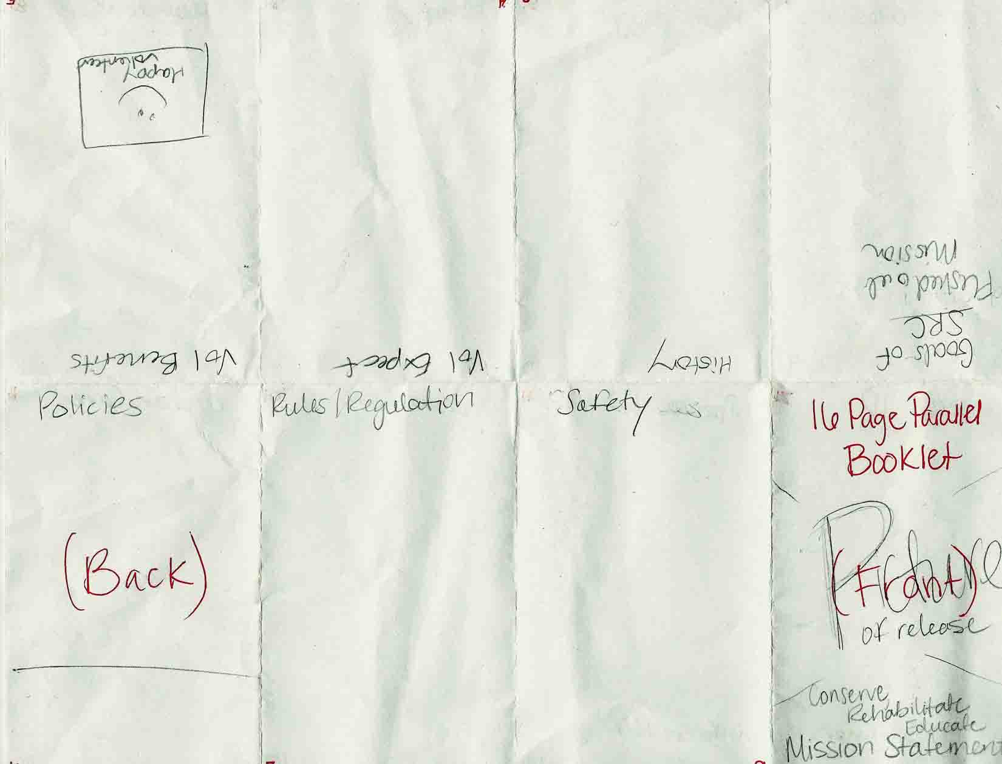

Figure 1: The front of our complex fold document.

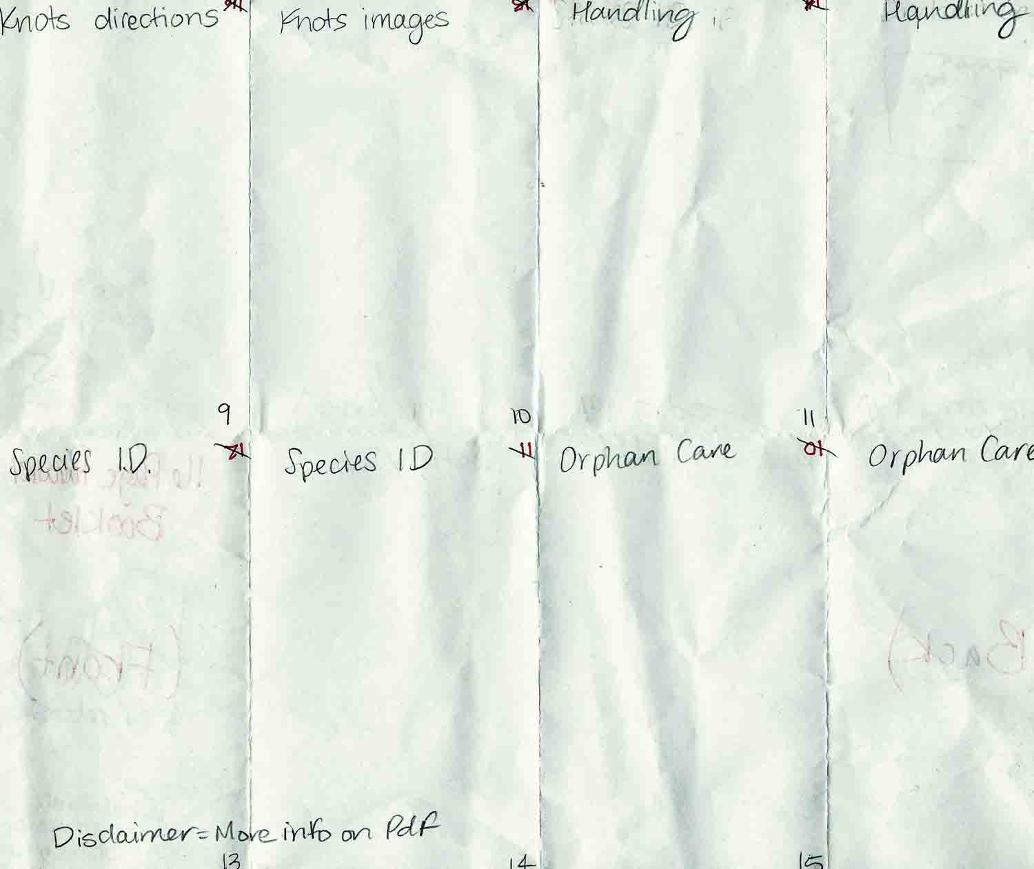

Figure 2: The back of our complex fold document.

The center of the inside of the brochure details the knot instructions. Initially we had intended to images with text, but after taking the photographs, we decided the images could work independently without the text. The images worked to demonstrate the knot tying experience as Barry (1997) expresses: “what visual images express can only be approximated by words, but never fully captured by them. Words represent an artificially imposed intellectual system removed from primal feeling; images plunge us into the depth of experience itself” (p. 75). The five images selected demonstrate the main steps within the knot process.

Another design choice that we made supports the ideals that Sam Dragga and Dan Voss present in their essay, “Cruel Pies of Inhumanity of Technical Illustrations” (2001). Dragga and Voss claim that it is unethical for “conventional illustrations [to] offer inhumanity as though it were objectivity” which, in turn, can dehumanize the meaning behind the illustration (p. 265). With this in mind, we elected to use real images of raptors and raptor handling throughout our handling and orphan care sections in order to stress to our users that they are handling living creatures and should do so in a respectful and delicate manner.

**Problems and Solutions**

One of the biggest problems that we have encountered over the course of this design project is that it is difficult to visit the SRC without prior security clearance. Rather than visiting the center as a group at our convenience, three of our group members have to obtain special permission before being granted entrance into the center. Because of this, most of our communication with the client is conducted by one group member who also serves as a long-time volunteer with the organization and has exclusive access to the center.

Related to the above-mentioned problem, prior to our visit to the SRC for usability testing on Wednesday, November 20, 2013, we also had not yet met Mrs. Mathews, who serves alongside Ms. Crandall as the facility’s other rehabilitation volunteer coordinator. However, we met Ms. Mathews when we did usability testing this week and were able to solicit her feedback on the current design of the brochure.

Prior to this week, another problem we had was a lack of images for the document. On Tuesday, November 19, 2013, Dana and Katy visited the center and took pictures of various species that will be included in the brochure. Any pictures these two members were unable to capture were provided by the SRC from their archived image files.

**Team Members’ Contributions**

Each of our group members collaborated on components of the design and written portions of the document. We all visited the client as a group for our first meeting to discuss the client’s needs and expectations. Similarly, we will all meet the client as a group during the first week of December to deliver our final product. The following sections describe each group member’s individual efforts in detail.

*Katy*

Katy has served as our main point of contact with our clients, given her history of volunteering at the SRC and the fact that she is able to visit the center at any time because she has clearance to do so. To that end, she has been in communication with Ms. Crandall and Ms. Mathews regarding the design of the document, set up meetings for the rest of the group to visit the SRC for pictures and usability testing, and provided us with substantial portions of content for the brochure based on her knowledge of raptors.

In the brochure, Katy wrote the sections on orphan care, raptor handling, and descriptions of the raptor species. She is also working on compiling a supplementary PDF that contains additional information we could not fit on the brochure due to space constraints.

*Dana*

Dana has been primarily responsible for creating and manipulating the InDesign file for our document. She has also created a vector file that contains the mission logo on the front of the brochure, in the event that our clients want to reuse or resize it.

She was also our group photographer; she captured most of the pictures of raptor species that appear on the inside of the brochure and those that show Katy demonstrating proper handling techniques.

In the brochure, Dana was responsible for including sections on the history of the SRC and its goals. Unfortunately, the history section had to been excised almost entirely from the document due to space issues; however, it will appear in the PDF.

*Courtney*

Courtney has been partly responsible for written components of the project, including the proposal and progress report.

She also put together a posttest questionnaire for usability testing, was present and took notes during usability testing at the SRC, and compiled notes that the group will use in revising and finalizing our design for the document.

In the brochure, Courtney was responsible for writing sections on policies, regulations, and safety.

*Troy*

Troy has been partly responsible for written components of the project, including the proposal and progress report. She was also present during usability testing at the SRC and took notes that the group will use in revising our document’s design.

Prior to our first meeting with our client, Troy created several low-fidelity (K & H, p. 315) paper brochure options to show to our client for review. One of her creations—a 16-panel, single-sheet, complex-fold document—was the option chosen for the prototype design for our brochure. She also generated a client interview questionnaire/record sheet (Appendix B) that was used during the initial client meeting.

In the brochure, Troy was responsible for writing the sections on volunteer benefits and expectations.

**Usability Testing**

Courtney and Troy conducted usability testing of the prototype document with three volunteers at the SRC on Wednesday, November 20, 2013. Three current SRC volunteers (two who have been volunteers for longer than one year and one first-semester volunteer) were tested in order to ensure that the design and content of the brochure is optimal for actual members of our user population. Before implementing final revisions to the design of our document, we also plan to test two non-volunteers in order to verify that the information present in our document is clear and concise.

The brochure was printed in color on glossy card stock. Users were given a folded prototype of the brochure as well as a non-folded one so that the full-page design with the raptor species identification pictures and pictures of how to tie a falconer’s knot would be as easy to see and read as possible.

*The Usability Test*

Our method for usability testing was to encourage users to use the concurrent think-aloud protocol in accordance with van den Haak et al.’s (2007) findings (p. 70). Troy and Courtney recorded users’ observations, thoughts, gestures, and comments as they looked over the document and, in some cases, asked prompting questions (e.g. “What do you think about the organization of the information?”) to obtain feedback from them. After users looked over the document and verbally shared their thoughts with us, we then asked them to fill out a posttest questionnaire of ten questions (see Appendix A) in order to gain further insight from them about their experience with the document.

In accordance with Howarth et al’s (2007) methodology, we plan to group our raw usability data in order to uncover larger usability problem instances. We also plan to use Barnum’s (2010) suggested method of grouping usability issues into global and local findings (pp. 262-263). After organizing and analyzing the data we collect, we will then use insights gained from usability testing the document to modify and revise our final design.

**Timeline**

The figure below demonstrates the completion dates of all of the objectives thus far as well as the date of our final usability testing and our projected date of completion:

**References**

Barnum, C. (2010). *Usability Testing Essentials*. Burlington, MA: Morgan Kaufman/Elsevier.

Barry, A.M. (1997). *Visual Intelligence: Perception, Image, and Manipulation in Visual*

*Communication* (pp. 69-103). New York: State University of New York.

Dragga, S. and Voss, D. (2001). Cruel Pies: The Inhumanity of Technical Illustrations.

*Technical Communication* 48(3), 265-274.

Howarth, J. et al. (2007). A Structured Process for Transforming Usability Data into

Usability Information. *Journal of Usability Studies*, 3(1), 7-23.

Kimball, M. A. and Hawkins, A. R. (2008). *Document Design: A Guide for Technical*

*Communicators*. Boston, MA: Bedford/St. Martin’s.

van den Haak, M. et al. (2007). Evaluation of an Informational Web Site: Three Variants of

the Think-Aloud Method Compared. *Technical Communication* 54(1), 58-71.

**Appendix A: Usability Posttest Questionnaire**

*Safety*

1.  Does the document contain adequate safety information? Is there any way the safety warnings could be made clearer?

*Content Evaluation*

2.  Please describe any information that seemed irrelevant or inaccurate.

3.  Please describe any information that you feel requires further explanation.

*Organization & Style*

4.  Is the document well organized? If not, please give suggestions for improvement.

5.  Please describe any information that you misunderstood on first reading or that you couldn’t understand at all. How might this information be made clearer?

*Design*

6.  Give examples of information that might be clarified by a visual image.

7.  Were any of the visual images misleading or overly complex? If so, please describe these images and explain what is confusing about them?

8.  Please describe any other problems with the overall design of this document.

*Overall Usability*

9.  Please suggest any other ways you can think of that would make this document easier to use.

10.  Do you feel that the information presented in this document is suitable for new volunteers at the Raptor Center? Why or why not?

**Appendix B: Initial Client Interview Record Sheet**

*\*NOTE: Each question included blank lines underneath it for group members to record responses and notes.*

1. What are your expectations of this document?

2. How do you envision the finished project?

3. How do you want this document to be used?

4. Describe the users of this documents. (We know they will be volunteers but how d

5. How often would you like us to update you with progress?

6. Can you think of any problems or concerns we might encounter over the course of completing this document?

7. What format do you see being created? (e.g., brochure, map fold, pocket fold). How will it be folded? (e.g., by hand or by machine?)

8. Are there any designs or design elements that you want to see in this publication? (e.g., color scheme, typefaces, logos, images, or new designs?)

9. Are there any phrases or keywords you would like us to include in the document?

10. Other notes: